**Call By Value:**

**#include<iostream.h>**

**#include<conio.h>**

**void change(int a)**

**{**

**a=20;**

**cout<<endl<<"In function:A="<<a;**

**}**

**void main()**

**{**

**int a=10;**

**clrscr();**

**cout<<"Before function call:A="<<a;**

**change(a);**

**cout<<endl<<"After function call:A="<<a;**

**getch();**

**}**

**Output:**

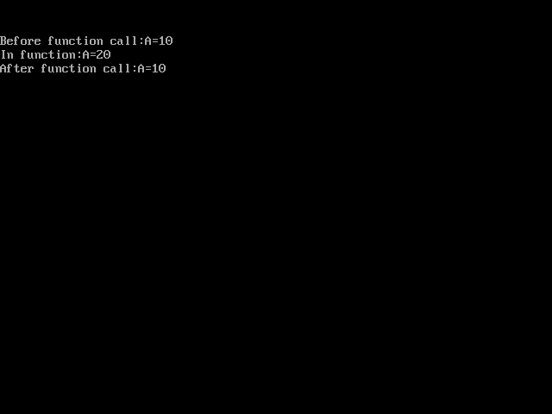

**Call By Address:**

**#include<iostream.h>**

**#include<conio.h>**

**void change(int *a)**

**{**

**\*a=20;**

**cout<<endl<<"In function:A="<<*a;**

**}**

**void main()**

**{**

**int a=10;**

**clrscr();**

**cout<<"Before function call:A="<<a;**

**change(&a);**

**cout<<endl<<"After function call:A="<<a;**

**getch();**

**}**

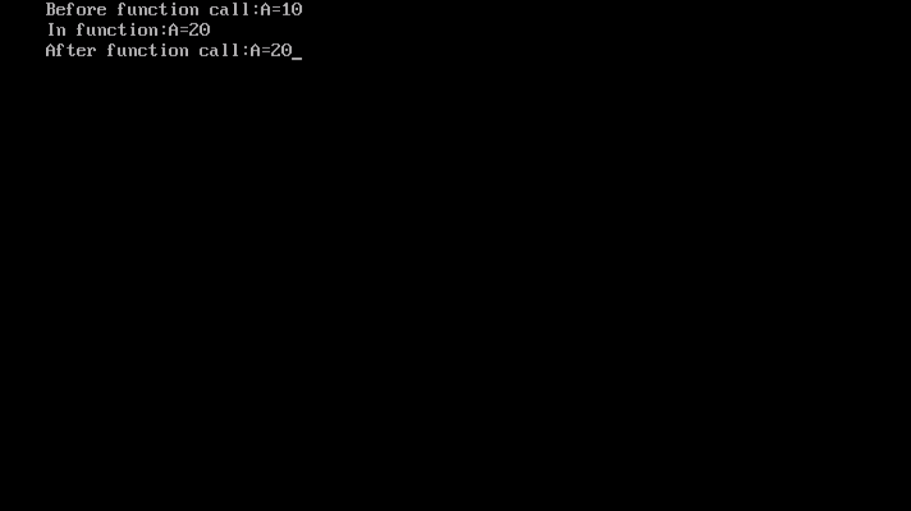

**Call by Reference:**

**#include<iostream.h>**

**#include<conio.h>**

**void change(int &x)**

**{**

**x=20;**

**cout<<endl<<"In function:A="<<x;**

**}**

**void main()**

**{**

**int a=10;**

**clrscr();**

**cout<<"Before function call:A="<<a;**

**change(a);**

**cout<<endl<<"After function call:A="<<a;**

**getch();**

**}**

